# Cube

This model is built to replicate dice, but a bit bigger, leaning in to the idea of the object being multi-use. To use this object, you must touch four of the sides to the screen in a certain pattern and the authentication will complete.

The order of the side to touch to the screen is the side showing 4 pips, then 1 pip, 4 pips and finally 2 pips. When you touch the object to the screen you must ensure that you are touching any of the black pips on any of the sides, as well as not touching the screen of the phone at any point during the authentication once you have started as this will cause the authentication to fail.

# 

Fig. 1, Example use of the model, with 4, 1 and 2 being input (from the left). The face touching the screen determines which number is being input.

# Credit Card

This model is built to the standard size of a credit card (with some added thickness to ensure the plastic doesn’t break) meaning it can fit in a wallet or purse. To use the model, you must enact a ‘turning’ motion over the ring of dots much like you would turn a safe lock, with the model on your phone as shown.

Starting from any of the dots, but for instructional purposes this will show the top-most dot, run your finger over 4 dots in a clockwise direction (Fig 1., starting at the circled dot), then 6 in an anti clockwise direction (Fig. 2, continuing from the circled dot). Finally, ensuring you are not touching any of the other points, tap the rectangle and the authentication is complete (Fig 3.).

Fig. 1, Starting from the topmost dot, run your finger in a clockwise direction over 4 more dots.

Important to note, do not touch the phone screen at any point after starting the authentication, and do not move the object, as the authentication relies on the touch points remaining in the same place on the screen, as such, place the object on the screen initially in such a way that none of it is hanging over the edge.

Fig. 3, Finally, release your finger from the final dot touched, and tap the rectangle once.

Fig. 2, Keeping your finger on the model, run your finger in an anti-clockwise direction over 6 more dots

# Pendant

This model is built to act as a pendant that could go on a keychain or necklace. The main idea of this model is to act like a combination lock – turn the layers to the right combination then touch to the screen to unlock your phone.

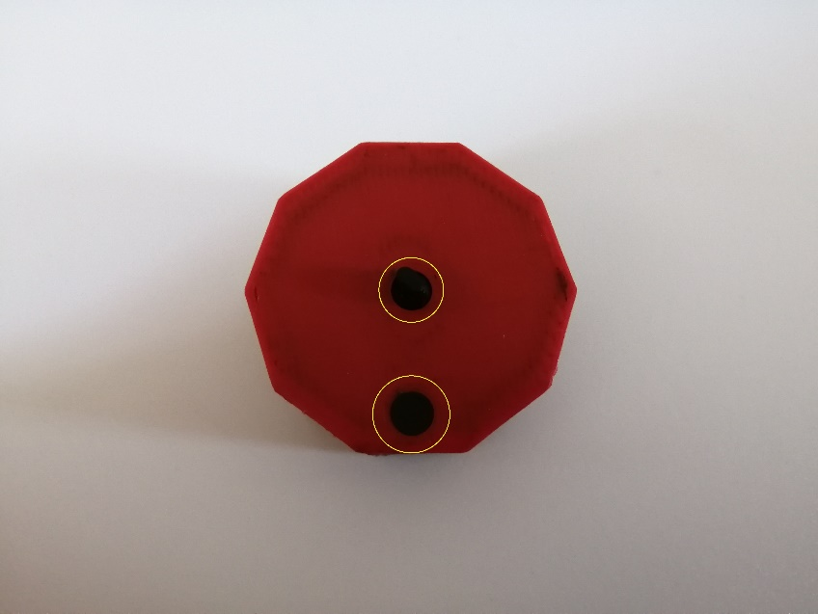On the each side of a layer, there will be a number. Align the layers with the numbers 1, 2 and 3 in a column from the top, once the phone is ready, place the object on the phone screen and touch both touch points to authenticate. Do not touch the screen at any point during the authentication, as this will likely make the authentication fail.

Fig. 1, the layers should be aligned with the numbers 1,2,3 in a column

Fig. 2, the two black dots on the top of the pendant should then be touched when the pendant is place on the phone screen